CS 2302

Lab 6 Report

Author: David Ayala

ID: 80617838

Instructor: Diego Aguirre

TA: Gerardo Barraza

**Introduction**

The purpose of this lab was to Implement the following graph algorithms, Kruskal’s algorithm and Topological sort. There isn’t much more to say other that. We could (“Feel free to use the instructor’s implementation of the Disjoint Set Forest and Graph data structures. Do at least one of the following to test your implementations”). And that’s it.

**Proposed Solution & Design Implementation**

So I knew that I would use Disjoint Set Forest and Graph data structures, to make them work so that is what I did, to first create the graphs that are modifiable. I then had to some of the pseudo code that Diego gave x number of days age and I also had to actually do the different algorithms by on paper that way I could actually be able to know how the algorithms in code. Once that was done, I tried my best in implementing them thru code. (not completely sure if they work)

**Experimental Results**

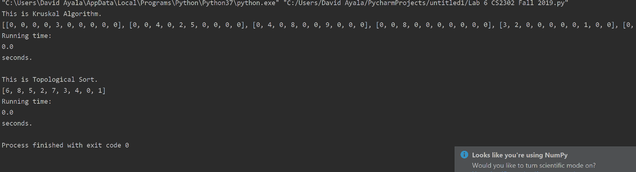

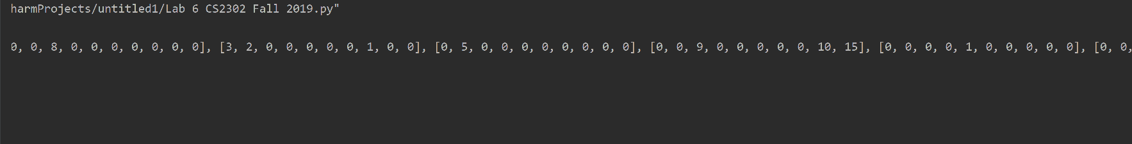

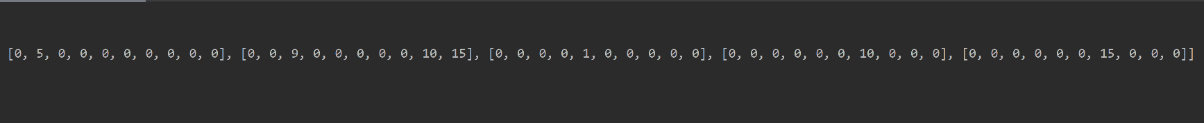

**Conclusion**

This lab allowed me to remember how to make graphs using code. It also served as practice for doing the algorithms by hand on paper and it actually helped prepare me for the exam somewhat. I also think that I was able to implement the two algorithms but like I said I’m not completely sure, but I tried to the best of my abilities. Which as the exam so far have been say is not much.

**Appendix**

This is where the code should be but that was like 5 different files so I didn’t add them here cause that’s a lot here’s a picture showing what I mean. Also you have my Github like other wise you would not be reading this, so it there if you want to look back at it.

